Customer Agreement - Medical Appointment Management Platform

Hygeia offers a software for managing medical patient data, referred to as “the platform”. This customer agreement is defined between the company Hygeia, the entity collecting patient data, hereinafter referred to as "the medical company", and individual users of the software, hereinafter referred to as "the user". Employees of the medical company may create a user with additional permissions in the platform, referred to as an “administrator”, or “administrative user”.

1. Services and Scope

A. Access to the platform

Hygeia will offer a medical company access to the platform, based on the pricing agreement (see section 9). Administrators have special user rights and will have full access to the data (excluding passwords) of the non-administrator users. The medical company may then provide users with access to the medical appointment management platform. The platform allows users to schedule and manage medical appointments, access their medical history, receive notifications and reminders, and facilitates billing through health insurance management.

B. Authentication and Access to Medical Data

The user agrees that authentication on the Platform will be done through [authentication method]. Passwords will only be stored in an encrypted manner. By using the platform, the user consents to the platform connecting to their electronic health record (EHR) information necessary for appointment management and billing services.

C. Appointment Management and Communication

The platform offers an interface for scheduling medical appointments, sending notifications and reminders to the user when they have an upcoming medical appointment or when there have been changes to their appointment, and providing tools for the efficient management (i.e. viewing, deleting, re-scheduling) of the user’s medical appointments. Administrative users may view, delete, or re-schedule all of their users’ medical appointments and all of these actions will notify the appropriate user. When users create their account, they consent to receiving the aforementioned notifications. All users may opt out of receiving these communications at any time. The third-party platform Mailchimp is used to manage notifications and subscription preferences.

D. Billing and Insurance

The platform will provide an interface for administrative to create and assign bills to non-administrator users using the health insurance information provided by these users. Users can then view the bills assigned to them within the platform. The user is responsible for providing accurate and up-to-date information about their insurance coverage.

2. Privacy and Confidentiality

Hygeia is committed to maintaining the privacy and confidentiality of user data, including medical information obtained from medical records and medical devices. User information will not be shared with third parties without the explicit consent of the user, except as required by applicable laws and regulations in the jurisdiction of the user. Should a data breach occur and a third party obtain access to user data without their consent, the user will be notified in a timely manner in congruence with the GDPR Article 4(12).

3. User Responsibilities

The Client is responsible for maintaining the confidentiality of their Platform login information. In addition, the Client is responsible for providing accurate and up-to-date health insurance and medical history information.

4. Limitation of Liability

Hygeia assumes no liability for any loss or damage arising from the use of the Platform, except to the extent that such damage is caused by gross negligence or willful misconduct on the part of the Hygeia.

5. Governing Law and Jurisdiction

This agreement is governed by the laws of the country where the medical company is registered and pays taxes. Any dispute arising in connection with this agreement shall be subject to the exclusive jurisdiction of the courts of this country. Hygeia reserves the right to refuse access to the platform based on the location of the medical company.

For the purpose of the General Data Protection Regulation (EU) 2016/679, the data controller is Hygeia, a company registered in Spain with the tax number xxxxx, with its registered office at xxxxx. All data is thus stored within the European Economic Area.

6. Pricing

The medical company will agree to a pricing plan upon signing this customer agreement. The plans available and their corresponding features are outlined below:

|  |  |  |  |
| --- | --- | --- | --- |
| Feature Description | Basic Plan | Premium Plan | Educational Plan |
| Base monthly price | 300€ | 500€ | Free* |
| Administrative users | Up to 5 | Unlimited | Up to 10 |
| Non-administrative users | Up to 1000 | Free up to 1000, each additional 1000 users cost an additional 150€ | Up to 1000 |
| Appointment viewing, deletion, and re-scheduling | Supported | Supported | Supported |
| Billing Management | Supported | Supported | Supported |
| Data Export |  | Supported | Supported |
| Service Level Agreement |  | Supported |  |

The educational plan is only available to students and educators at a registered university within the European Union. A university email is required when creating this account.

A payment method will be provided upon signing of the customer agreement and the medical company consents to the automatic collection of the monthly fee, including any overage charges. If payment cannot be collected, all user accounts will be suspended within one month of the failure to pay.

Service may be terminated by the medical company at any time but a full month’s payment is due if the platform has been accessed at all during the month. Hygeia will continue to offer access to the platform as long as payment is received. The monthly base price and overage fee may be increased once annually based on the official Spanish inflation rate.

7. Service Level Agreement

Subscribers to the Premium Plan additionally receive the following service level agreement.

The platform will have an availability of 95% or higher. If the platform is offline between 90%-95% of the month, then the monthly fee and overage charges are waived for that billing period. If availability of the platform drops below 90%, then the medical company is entitled to service credits equivalent to 3 months of use of the platform, based on the previous 3 billing periods.

By accepting the terms and conditions of this Agreement, the Customer acknowledges that it has read, understood and agreed to all the provisions set forth herein.

__________________________

Pricing Justification

Mailchimp has a base pricing plan, but has limits on the amount of contacts and emails that can be sent monthly. There are overage charges based on 1000 new contacts. Thus, if a medical company acquires too many new users, the bill for mailchimp will increase.

<https://mailchimp.com/en/help/about-additional-charges/>

As the number of users increases, the performance of the platform may also decrease. Thus, offering more instances of the microservices will be required to maintain performance and availability of the platform. Datadog adjusts their pricing based on how many hosts (in our case, microservices) are connected. To maintain performance as the number of users grows, the datadog fee will also increase.

<https://www.datadoghq.com/pricing/>

The educational plan is offered to students and researchers as a marketing technique. If medical students get to know this platform in their university environment, they are more likely to adopt it in a future office when they leave school.

**Claudette Evaluation:**

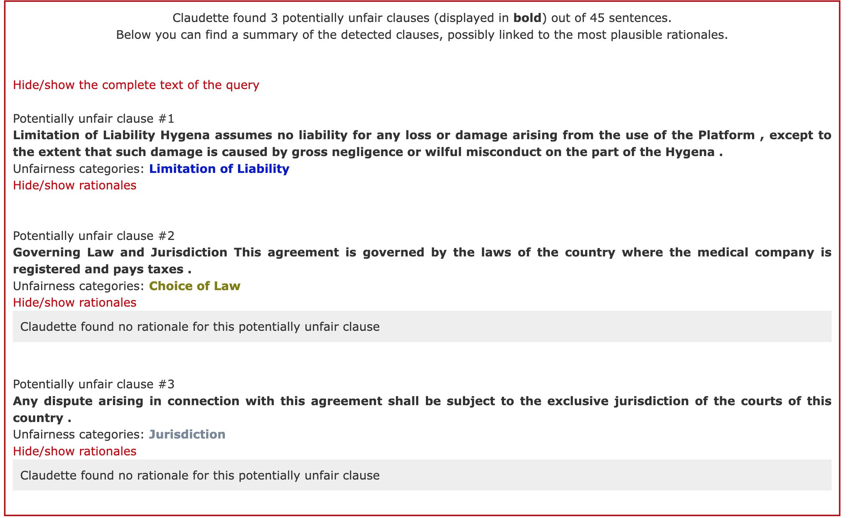

The parts highlighted by Claudette do not violate the fairness clause when viewed in context.